|  |  |  |  |
| --- | --- | --- | --- |
| **Unit Plan**  ***Evangeline*** | | | |
| Text: *Evangeline*, Longfellow | | Length of Unit: (7-9) lessons, intended to be inserted into LDOE *Evangeline* Unit, grade 9 | |
| Guiding Questions:  How does the epic genre reflect a society’s cultural or historical background?  How does the journey narrative impact character development and characterization?  How does an author’s choice of structure or form relate to author’s purpose? | | | |
| CCSS addressed:  CCSS W9.7  Conduct short as well as more sustained research projects to answer a question (including a self-generated question) or solve a problem; narrow or broaden the inquiry when appropriate; synthesize multiple sources on the subject, demonstrating understanding of the subject under investigation  CCSS RL9.3  Analyze how complex characters (e.g., those with multiple or conflicting motivations) develop over the course of a text, interact with other characters, and advance the plot or develop the theme.  CCSS RL 9.4  Determine the meaning of words and phrases as they are used in the text, including figurative and connotative meanings; analyze the cumulative impact of specific word choices on meaning and tone (e.g., how the language evokes a sense of time and place; how it sets a formal or informal tone).  CCSS RL 9.9  Analyze how an author draws on and transforms source material in a specific work (e.g., how Shakespeare treats a theme or topic from Ovid or the Bible or how a later author draws on a play by Shakespeare) | | | |
| Before Reading | | | |
| Lesson | Description of Instruction | | Standards, Outcomes |
| **Mini Research Project** | Students will immerse themselves in the background of the Acadians in preparation for a study of *Evangeline*.  Students will peruse print, video, and song sources to gain knowledge useful to the study of the text. | | CCSS W9.7  Conduct short as well as more sustained research projects to answer a question (including a self-generated question) or solve a problem; narrow or broaden the inquiry when appropriate; synthesize multiple sources on the subject, demonstrating understanding of the subject under investigation |
| Duration: 2 lessons |
| Materials: |
| Access to internet |
| During Reading | | | |
| Lesson | Description of Instruction | | Standards, Outcomes |
| **Vocabulary Study** | Students will take note of words while reading that either are unknown or are important to the understanding of the text.  Special care will be taken to examine the connotation and denotation of vocabulary in context of understanding character. | | CCSS RL 9.4  Determine the meaning of words and phrases as they are used in the text, including figurative and connotative meanings; analyze the cumulative impact of specific word choices on meaning and tone (e.g., how the language evokes a sense of time and place; how it sets a formal or informal tone). |
| Duration throughout the reading of the text as needed |
| Materials  Evangeline Vocabulary Chart printed |
| **Use of Allusions** | Teacher will review the literary device allusion. While reading, students will stop to make note of and research (if background knowledge is insufficient) the original source material. Students will then work to examine the effect of the allusion within the text. | | CCSS RL 9.9  Analyze how an author draws on and transforms source material in a specific work (e.g., how Shakespeare treats a theme or topic from Ovid or the Bible or how a later author draws on a play by Shakespeare) |
| Duration  Throughout the reading of the text |
| Materials |
| Graphic organizer my be made accessible as a differentiation method |
|  |
| **Examining the Epic Hero- Character Development** | * **Activating Prior Knowledge-**Discuss characteristics of a hero and have students write them down (ex. Strength, super powers, bravery, etc.) * Have students brainstorm and discuss what they believe an epic hero is * View video on [What Makes a Hero](https://www.youtube.com/watch?v=Hhk4N9A0oCA) and discuss the characteristics of an epic hero * While reading *Evangeline*, discuss how the character, Evangeline, falls into the category of epic hero rather than just a hero * Begin completing the Epic Hero Cycle Graphic Organizer * **Exit Ticket Question**: *What is the difference between a hero and an epic hero? Why would a character such as Superman or Spiderman not fall into the epic hero category? What makes Evangeline an epic hero?*   **Duration:** 1 day  **Materials:**   * Epic Hero Cycle Graphic Organizer * [**What Makes a Hero**](https://www.youtube.com/watch?v=Hhk4N9A0oCA) **video** | | * **CCSS RL9.3**-Analyze how complex characters (e.g., those with multiple or conflicting motivations) develop over the course of a text, interact with other characters, and advance the plot or develop the theme * Students will understand the difference between a hero and an epic hero. Students will examine the characteristics of the epic hero and the hero’s journey. Students will determine how Evangeline is an epic hero and will complete the Epic Hero Cycle Graphic Organizer. |
| Duration |
| Materials |
| After Reading | | | |
| Lesson | Description of Instruction | | Standards, Outcomes |
| **Comparing the Quests: Drawing Comparisons Across Epics** | As a summative assessment, Students will draw comparison amongst epics. Using the epics previously studied (*The Odyssey, Evangeline,* and portions of *The Aeneid* and *Ulysses*), student should complete a self generated organization chart. The focus should be on identifying characteristics all epics share, and then making distinctions between epics after identifying characteristics.  If students need assistance, the teacher may suggest characteristics like **form**, **hero**, **journey**, etc to examine.  Students will use these characteristics to begin to draw distinctions between and comparison amongst the epics.  Students will use this as prewriting for an essay. The teacher may decide to have students self generate thesis statements or respond to a prompt like: **How does *Evangeline* compare to the epics that precede the text?**  The teacher may include any specific writing lessons as necessary and assess the essay with a rubric of their choosing.  A sample graphic organizer has been provided. | | **CCSS W9.1**  Write arguments to support claims in an analysis of substantive topics or texts, using valid reasoning and relevant and sufficient evidence. a. Introduce precise claim(s), distinguish the claim(s) from alternate or opposing claims, and create an organization that establishes clear relationships among claim(s), counterclaims, reasons, and evidence. b. Develop claim(s) and counterclaims fairly, supplying evidence for each while pointing out the strengths and limitations of both in a manner that anticipates the audience’s knowledge level and concerns. c. Use words, phrases, and clauses to link the major sections of the text, create cohesion, and clarify the relationships between claim(s) and reasons, between reasons and evidence, and between claim(s) and counterclaims. d. Establish and maintain a formal style and objective tone while attending to the norms and conventions of the discipline in which they are writing. e. Provide a concluding statement or section that follows from and supports the argument presented. |
| Duration  3-5 lessons |
| Materials |
| Copies of the epics |
|  |
|  |
|  |
|  |

**Historical Setting**

“Evangeline” is set in America’s Pre-Colonial Period, wherein the initial conflict of the epic poem begins to unfold with the Expulsion of the Acadians (1755), also known to historians as the Great Upheaval or the Great Expulsion. To understand the nature of this political expulsion, one must first consider the early explorations and settlements of America. The rival nations of France and England each pursued their own campaigns to lay claim on the undeveloped territory. In *The Acadians: Their Deportation and Wanderings*, author George P. Bible describes this tension: the struggle for supremacy of these two ancient enemies; their differences of character, temperament and religion; the overlapping grants of territory; the indefinite boundaries; the uncertainty which attained to rights acquired by discovery and the claiming of vast expanses of territory, and the extent of which both the early explorer and the claimants were ignored (18). However, prior to the French and English explorations, disputes, and tensions on claim and control, the Acadians existed in their own independent and peaceful community before such—as early as 1604. Acadia, as it was originally known to the French and English, embraced part of the state of Maine, all of New Brunswick, Nova Scotia, Prince Edward Island, the island of Cape Breton, and the smaller islands of the Northeast. It should be stressed that Acadia, unlike the French and English adventurers and explorers, was settled by families.

As English efforts secured the territory, joint forces of British troops and American colonists sought out French forts and occupancies for expulsion and dispersion. Because of their French heritage, Acadians were included in these movements to expel and, intentionally, separate and disperse communities and families. During the first wave of expulsions, the Acadians were dispersed among the thirteen colonies. The expulsions and dispersions left many families wandering the uncharted country, in search of loved ones.

“Evangeline” takes its opening in this first wave of the Great Expulsion. Grand-Pre, the “forest primeval,” or modern Nova Scotia, is the home village of our Heroine. She is about to undertake a wandering journey as her people find exile, refusal, and hardship. However, the theme of Exile and Return takes shape as a discovery and founding of a new home for her people provides climax.

Video link:

<https://youtu.be/ihwnTAFgaOA>

Song link:

<https://www.youtube.com/watch?v=te7KW4K-00E>

*Evangeline* Vocabulary Chart

|  |  |  |  |  |
| --- | --- | --- | --- | --- |
| **Word** | **Connotation** | **My Definition/ Part of Speech** | **Synonyms, Antonyms, and Similar Words (Word Family)** | **Pictures and Source Sentence** |
| Primeval |  | Adjective/Of or relating to the earliest ages | Syn: Ancient    Ant: Modern | This is the forest primeval; but where are the hearts that beneath it Leaped like the roe, when he hears in the woodland the voice of the huntsman? |
| Missal |  |  |  |  |
| Heirloom |  |  |  |  |
| Dubious |  |  |  |  |
| Creole |  |  |  |  |
| Vespers |  |  |  |  |
|  |  |  |  |  |
|  |  |  |  |  |
|  |  |  |  |  |

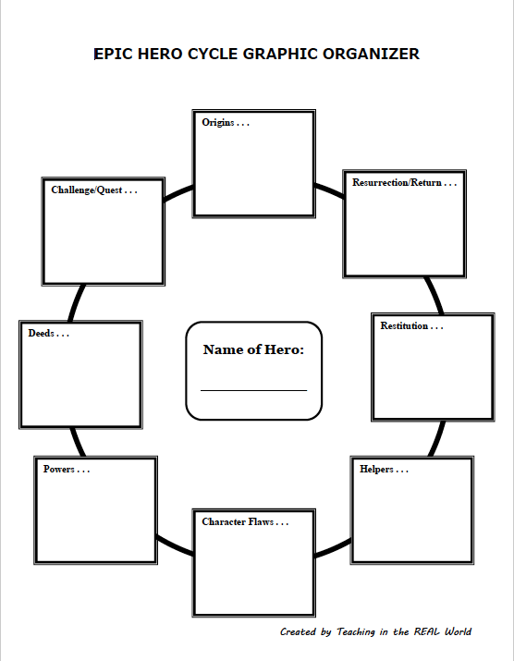

**Epic Comparisons Graphic Organizer**

|  |  |  |  |  |
| --- | --- | --- | --- | --- |
|  | *Evangeline* | *The Odyssey* | *The Aeneid* | *Ulysses* |
| Form |  |  |  |  |
| Hero |  |  |  |  |
| Journey |  |  |  |  |
|  |  |  |  |  |
|  |  |  |  |  |
|  |  |  |  |  |

Team Members  
Spring 2019 Quarter

Burns, Brooke  
Becker, Lance  
Laprarie, Kasi  
Guillory,  Lauren  
Wroten, Christian  
Artero, Grant  
Bagley, Destin  
Hild, Irene