Louisiana Tech University Clinical Lesson Plan Template
Author(s): Bruce R. Magee |  |  | Date Written: October 15, 2018
School: NA |  | Grade: 11 | Subject: English
Lesson Topic: Samuel Clemens letter to his sister, March 9-11, 1859 |  | Date Taught: January 21, 2019 | Time Frame: 50 minutes
Demographic Data
Number of Students: NA |  | Gender: NA | IEP/504: NA
Race/Ethnicity: NA |  |  | Language(s): NA
Lesson Foundations
- Content Knowledge Connections
Assessment Data (formative/summative assessments, observations, etc.) | - NA.  - I’m planning the lesson with the assumption that most of the students can read, but not all at the same level.
Prerequisite Learner Knowledge/Skills | - They need to be able to read and write.  - They need basic research skills.  I’d like them to have general knowledge about  - Letters  - Sam Clemens  - Mardi Gras
Learner interests, needs, etc., to inform selection of learning outcomes and differentiation | - Louisiana children have a natural interest in our state’s culture, especially Mardi Gras.
Describe how this lesson fits within a unit or sequence of lessons | - This is the first lesson of five. It will introduce the letter of Sam Clemens to his sister, Pamela Moffett.
Personal research on lesson topic | - The Mark Twain Project.  - Louisiana History courses in 8th grade and college.  - I’m the co-editor of the Louisiana Anthology website, and have edited numerous works related to Mardi Gras.  - I’m also the co-host of the Louisiana Anthology Podcast, and have interviewed several scholars about various Mardi Gras traditions.
- Learning Outcomes and Formal Measurable Objectives
Learning Outcome | Measurable Objective
Write | TLW write a paragraph in response to a picture.
Identify | TLW identify answers to questions based on the reading.
List | TLW list moods created by the letter.
- Standards Directly Connected to the Lesson (alphanumeric AND text)
ELA 11 RSL 3. Analyze the impact of the author’s choices regarding how to develop and relate elements of a story or drama, including how the author develops character and setting, builds the plot and subplots, creates themes, and develops mood/atmosphere.
ELA 11 RSL 4. Determine the meaning of words and phrases as they are used in the text, including figurative and connotative meanings; analyze the impact of specific word choices on meaning and tone, including words with multiple meanings or language that is particularly fresh, engaging, or beautiful. (Include Shakespeare as well as other authors.)
ELA 11 SLS 1.b. Work with peers to promote civil, democratic discussions and decision-making, set clear goals and deadlines, and establish individual roles as needed.
ELA 11 LS 1. Demonstrate command of the conventions of Standard English grammar and usage when writing or speaking.
ELA 11 LS 2. Demonstrate command of the conventions of Standard English capitalization, punctuation, and spelling when writing.
- Assessment
- Bellringer (5 minutes, 5 points)
- Notetaking (15 minutes, 15 points)
- Journaling (15 minutes, 5 points)
- Group work (10 minutes, 5 points)
- Exit ticket (5 minutes, 3 points)

- Classroom Preparation
Classroom & Class Organization (seating, grouping, etc.) | - The class will work as individuals and in groups.
Teacher/Student Materials | - Handouts (attached)  - Bellringer  - Guided note taking  - Journaling  - Group Work  - Exit Ticket
Technology Resources | - Computer  - Internet Connection  - Browser  - Powerpoint  - Projector  - Screen  - Speaker
Management Plan (behavior, time, etc.) | - Classroom timer  - Listen and follow directions.  - Raise your hand before speaking or leaving your seat.  - Keep your hands and feet to yourself.  - Respect your classmates and your teacher.

Pedagogy
- Lesson Introduction
- Bellringer: Imagine that you are one of the characters in the picture above. Write several sentences from that person’s perspective about what that Mardi Gras parade would be like.
- PPT slide of a reading of the first paragraph with music and images.

- Teaching Strategies
- Integrate technology into the lesson.
- Include popular culture
- Make time for journaling.
- Have students work in groups.

- Modifications/Accommodations
- Make sure the groups have students with different levels of abilities.

- Learning Activities
- Bellringer.
- Guided note-taking while I read March 9 part of the letter.
- Individual journaling listing the moods the story creates.
- Group work analyzing how Clemens creates those moods.
- Exit ticket.
- Closure
- Exit ticket.

Required Lesson Plan Reflection (See Pre-Conference form). Required Teaching Reflection (See Post-Conference form).

Sam Clemens’ Letter to Pamela Moffet
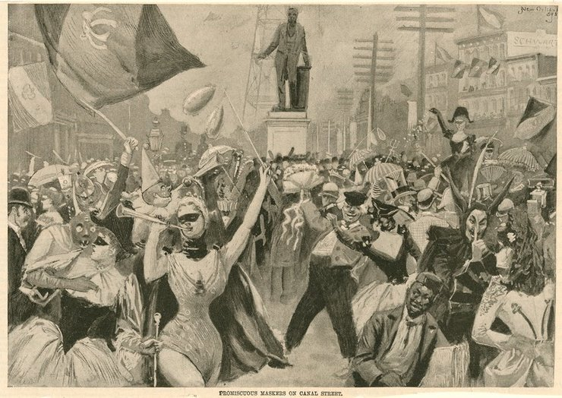
Bellringer: Imagine that you are one of the characters in the picture above. Write several sentences from that person’s perspective about what that Mardi Gras parade would be like. (5 minutes, 5 points)

Guided note taking (15 minutes, 15 points):
Clemens was in this city: ______________________ (1 point)
And saw this event: ___________________________ (1 point)
What was the first strange thing he saw? _________________________ (1 point)
What was the 18-year-old girl dressed as? _________________________ (1 point)
What did she do that surprised Clemens? _________________________ (1 point)
What was the name of the parade that Twain saw? ___________________________ (1 point)
What street did it parade on? _____________________________ (1 point)
List five of the things he saw in the parade: (5 points)

What were the themes of the parade? (4 points)

Journaling: Mood created by the story: Using your Mood Vocabulary list, write down at least 5 words that describe how the letter makes you feel. (10 minutes, 5 points)

Group work: How does Clemens create the moods you’ve identified? List words, phrases, images, etc., that contribute to the mood. Each group will present your findings to the class. (10 minutes, 5 points)

Exit ticket (3 points):
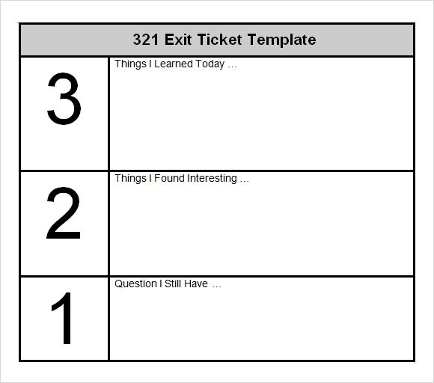

PRESS RELEASE
Dr. Magee’s English Classes will be studying Samuel Clemens’ experience of Mardi Gras in New Orleans. The unit will introduce students to the history of Mardi Gras in Louisiana. And there’s nobody better to introduce them to Mardi Gras than Samuel Clemens.
It’s the beginning of Lent, and all good Catholics eat and drink freely of what they please, and, in fact, do what they please, in order that they may be the better able to keep sober and quiet during the coming fast. It has been said that a Scotchman has not seen the world until he has seen Edinburgh; and I think that I may say that an American has not seen the United States until he has seen Mardi-Gras in New Orleans.
In this unit, we’ll learn about Mardi Gras both past and present. AND we’ll laissez les bon temps rouler!
Memo
To: Principal and teachers
From: Dr. Bruce R. Magee
Date: October 19, 2018
Subject: Unit on Samuel Clemens’ letter about Mardi Gras
My English Classes will be studying Samuel Clemens’ experience of Mardi Gras in New Orleans. The unit will introduce students to the history of Mardi Gras in Louisiana. And there’s nobody better to introduce them to Mardi Gras than Samuel Clemens.
It’s the beginning of Lent, and all good Catholics eat and drink freely of what they please, and, in fact, do what they please, in order that they may be the better able to keep sober and quiet during the coming fast. It has been said that a Scotchman has not seen the world until he has seen Edinburgh; and I think that I may say that an American has not seen the United States until he has seen Mardi-Gras in New Orleans.
In this unit, we’ll learn about Mardi Gras both past and present. AND we’ll laissez les bon temps rouler!

Letter to Parents
English Department
P. O. Box 3162
Louisiana Tech University
Ruston, LA 71272
Parents of Dr. Magee’s students
Dear Parents:
My English Classes will be studying Samuel Clemens’ experience of Mardi Gras in New Orleans. The unit will introduce students to the history of Mardi Gras in Louisiana. And there’s nobody better to introduce them to Mardi Gras than Samuel Clemens.
It’s the beginning of Lent, and all good Catholics eat and drink freely of what they please, and, in fact, do what they please, in order that they may be the better able to keep sober and quiet during the coming fast. It has been said that a Scotchman has not seen the world until he has seen Edinburgh; and I think that I may say that an American has not seen the United States until he has seen Mardi-Gras in New Orleans.
In this unit, we’ll learn about Mardi Gras both past and present. AND we’ll laissez les bon temps rouler!
Sincerely,
Bruce R. Magee

