Anthony Assoko Mve
English 212
Dr. Bruce Maguee
5/3/12
Congo Square
In the eighteenth century, black slaves who were brought from Africa to South Louisiana in New Orleans usually gathered every Sunday afternoons outside the city wall on the edge of the treme plantation in the southern corner of Louis Armstrong Memorial Park. Then, this place became officially named Congo Square or Plains in 1817. Both the enslaved and free Negroes performed many activities in order to preserve their heritage. These activities included drumming, music making, socializing, and dancing.
The key instrument for the cultural music expression was a long narrow African drum, which comes in different dimensions ranging from three to eight feet. In addition, they also used other instruments at Congo Square such as the triangle, the jawbone, and an instrument that was an early version of the banjo. Many of these instruments were made from reeds strung together like panpipes. The slaves started doing this to keep the African beat alive so that they will not lose their culture and allowed the tradition to continue from generation to generation.
Congo Square was also established by the slaves as the African market because food was in short supply during the 1730s and 1740s. Slaves were advised to grow their own gardens, hunt, and fish. Thus, in an exposed market, those slaves often shared, traded or sold the excess of their goods. This market was run outside city regulations and was the main source of private revenue for slaves as well as some free blacks.
In addition, Congo Square also characterized the unique place in America where African Americans could express their spiritual belief known as Voodoo. It was a dancing faith because of the approach of inducing spiritual possession via rhythms and manipulations of the dance. Each drum beat or rhythm was a signal to a different spirit to attend the convention. However, other types of dances were performed as well, such as the Bamboula, the Calinda, the Yanvalou, the Counjaille, and the Chacta.
Even though there is no recorded date of the last dance in the square, the practice declined gradually with the end of slavery after the American Civil War, but the square instead became a famous musical place with numerous series of brass band concerts by orchestras. Later in 1970, the city started the New Orleans Jazz & Heritage Festival held annually, which turned into a larger festival called New Orleans Fairgrounds. In the twenty-first century, Congo Square has continued to be an important site for music festival and a community gathering place for brass band parades, protest marches, and drum circles.

Today, New Orleans is recognized by some travel writers as the most Africanized city in the United States of America. Moreover, it is well-known for its Jazz music that resounds the rhythms of slave dance in Congo Square. Therefore, Congo Square has a symbolic importance to African Americans because of the role the square played as the musical heritage and a contribution to the origin of Jazz and other American musical forms.

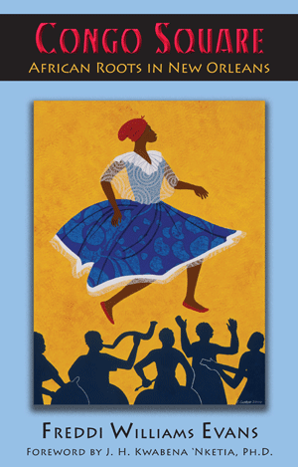
Source:African Roots in New Orleans, Freddi Williams Evans
Works Cited
“African Roots” in New Orleans | Octavia Books | New Orleans, Louisiana - Independent Bookstore." Octavia Books. Web. 25 Apr. 2012. <http://octaviabooks.com/book/9781935754039>.

“Keeping the African Beat Alive." Jass.com: Congo Square. Web. 25 Apr. 2012. <http://www.jass.com/congo.html>.

"Congo Square." ULPress.org. Web. 25 Apr. 2012. <http://www.ulpress.org/catalog.php?item=119>.

"Home." Web. 25 Apr. 2012. <http://www.congo-square.net/>.
“The Soul of New Orleans." The Black Box. Web. 25 Apr. 2012. <http://www.aaregistry.org/historic_events/view/congo-square-soul-new-orlea

“People United for Armstrong Park.” Web. 27 Apr. 2012. <http://www.pufap.org/park-amenities/congo-square/>.

