Alex Shelton
Louisiana Anthology 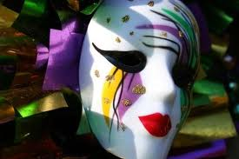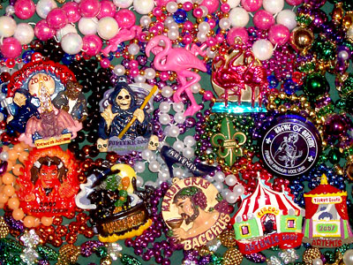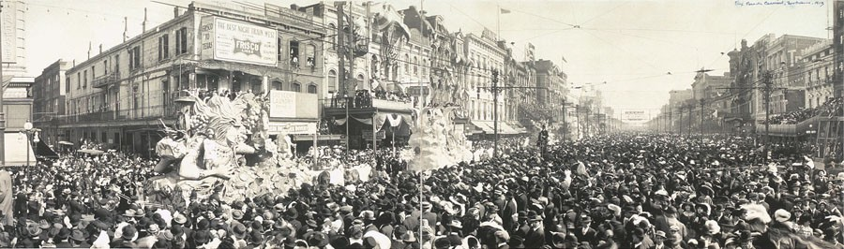

The History of Mardi Gras Beads
Mardi Gras is a very festive time of year, especially in the southern parts of the United States; it is a time of celebration before beginning the fasting season of Lent. Mardi Gras is celebrated on Fat Tuesday. It is not celebrated nationally throughout the entire United States but a number of traditionally French states and cities in the United States still have significant celebrations, one of those states being Louisiana. This holiday is celebrated in many different ways, from dressing up in costumes and wearing masks to pulling large and decorative floats behind a vehicle. How did such festivities begin in the first place though? There is an elaborate history behind Mardi Gras and its extravagant celebration that most do not know about. Though Mardi Gras means many different things to different people, there is a single item that is integrated into all Mardi Gras celebrations and that is beads, also referred to as throws, of every color, shape, and size.
Mardi Gras began in Louisiana as a French Catholic tradition. It was started by a man named Pierre le Moyne, Sieur d'Iberville in 1699. Pierre was sent, along with other troops, by the French to defend France’s claim on Louisiana and other states. On March 2nd Pierre and his men entered the mouth of the Mississippi River; the group proceeded up the Mississippi where they then setup camp about 60 miles south of New Orleans. On March 3, 1699 Pierre named the spot of their camp Point du Mardi Gras in honor of the holiday (Mardi Gras Wikipedia). Since then the celebration of Mardi Gras has grown tremendously but has still maintained a majority of its French heritage.
One of the first things that come to everyone’s mind when they think of Mardi Gras is, of course, beads. Bead throwing has not always been involved with Mardi Gras though. The first Mardi Gras parade took place in New Orleans in the 1830’s, but it wasn’t until The Rex parade in the 1920’s that people on the floats, also known as krewes, began to throw beads as part of the festivities of Mardi Gras. When the bead throwing phenomena was originally introduced in the Rex Parade the krewes would throw inexpensive handmade glass necklaces, far different from the beads that are thrown in today’s parades (Mardi Gras Beads History). The beads of today are much more iridescent and desirable than those of the 1920’s but the famous phrase “Hey, Mister, throw me something!” has still remained throughout time, along with some newer traditions of getting the attention of krewes, if you want to have some of those splendid beads thrown to you.
Since beads were first introduced the cries of people trying to get the attention of people on the floats passing by has gotten louder and louder every year. Thus the bead industry for them has grown larger and larger and more creative every year to satisfy all the parade goers. Many people do not know but the color of the Mardi Gras beads has a significant meaning behind them. The traditional colors are: purple, green, and gold. “Officially, they symbolize justice, faith and power. An association with frankincense, myrrh and gold from the legend of the three Magi has also arisen” (LeBoeuf-Little, Nicole). Modern folklore has a different meaning for the colors; according to it gold beads bring good luck while the white colored beads bring kisses (LeBoeuf-Little, Nicole). Today there are a variety of colors involved with Mardi Gras and many different shapes, sizes, and colors for beads. Other unique items are also thrown at parades such as plastic cups, Frisbees, masks, and even hats all having different things on them. However the beads are without a doubt the most popular items thrown in parades and are the most desirable to crowds.
Beads have evolved immensely since the 1920’s when it was first introduced by throwing handmade glass beads. Today beads are getting bigger and better; the most popular size is about 33” long. There are even some beads that are made in limited numbers, they are considered to be very rare and are treasured by parade goers. Though several new things have been introduced to the festivities of Mardi Gras the main tradition and the desire to catch beads still endure and are alive in parts of Louisiana today.
By: Alex Shelton
May 1, 2012

Works Cited
"Mardi Gras." Wikipedia. Wikimedia Foundation, 30 Apr. 2012. Web. 30 Apr. 2012 <http://en.wikipedia.org/wiki/Mardi_Gras>.
"Mardi Gras Beads History | Mardi Gras Beads Meaning | Mardi Gras Throw Beads." About Mardi Gras in New Orleans. Web. 30 Apr. 2012. <http://mardigrasday.com/mardigrasinfo.php?article_id=4>.
LeBoeuf-Little, Nicole. "What Do Mardi Gras Beads Represent?" EHow. Demand Media, 05 Aug. 2009. Web. 30 Apr. 2012. <http://www.ehow.com/facts_5272921_do-mardi-gras-beads-represent.html>.

