Krystal Fountain
English 210
Professor Magee

Myrtles Plantation
The plantation that is today known as Myrtles was once known by a different name. Some people may have heard it called Whiskey Dave, but the original name of the plantation was Laurel Grove(Wikipedia). This antebellum plantation is located in St. Francisville, Louisiana. St. Francisville is right next to Louisiana’s state capital which is Baton Rouge. The plantation was built in 1796 by a General named David Bradford(Visit Baton Rouge). Bradfords lived in Laurel Grove many years until he was needed for the Whiskey Rebellion in 1799. During this rebellion, President George Washington put out a order for the execution of Bradford. Bradford trying to hide from Washington moved to a plantation in Pennsylvania. Once Bradford died, his daughter’s husband managed the plantation(Wikipedia). He then moved to Covington, Louisiana and left a old caretaker to maintain the plantation. Later on the original owner’s daughter, her husband decided to sell the plantation and the slaves to a man named Ruffin Gray Stirling. Stirling and his wife did major remodeling to the plantation. Once the remodeling was done, the house had been doubled in size and the name was changed from Laurel Grove to Myrtles. This plantation was passed down within the family, and at one point they were forced to sell it. Later on the same was family was able to buy it back. In 1871, Winter, the owner at the time was shot and killed by a man on the porch of the plantation. His wife stayed at Myrtles, and plantation ownership stayed within the family. The debt became too large and was sold to new family, and then kept being passed from family to family until 1891. This is when Harrison Milton Williams bought the plantation.
A family member of the Williams had been noticing odd things happening around Myrtles, but nothing was done. Later the plantation was sold and restored by the Ward family, and then handed to a new family, and this time Myrtles was purchased by the Ward’s. The Ward family restored, and then sold to the Myers. A family member of the Myers published a book about haunted homes, which was featuring Myrtles. Some people have said that the plantation is haunted because the original owner, David Bradford built the plantation over Tunica Indian Burial grounds, which cursed the whole house. Myrtles supposedly had 12 ghosts, and had 10 murders that occurred(Wikipedia). The actual records only show that one person was murdered in the house, which was William Winter.
The plantation is today known as a full service restaurant and a bed and breakfast. The restaurant is called The Carriage House Restaurant, which is located on a 5,000 square foot old brick courtyard(Visit Baton Rouge). The house also offers tours to allow the visitors to experience, “One of Americas Most Haunted Homes.” Myrtles has been featured in New York Times, Oprah Show, The History Channel, Good Morning America, Haunting of Louisiana, and many more nation known medias(Myrtles Plantation). In the plantation a visitor can find antiques, architectural treasures of the South, hand painted stained glass, and maybe even encounter a ghost. The giant rocking chairs and the 10 acres of surrounding woods are also well known at the plantation.

Sources used
- "Myrtles Plantation." Web log post. Myrtles Plantation. Wikipedia, 27 Feb. 2012. Web. 3 Apr.
2012. <http://wikipeida.org>.
- Advertisement. The Myrtles Plantation. John Moss. Web. 12 Apr. 2012.
<http://www.myrtlesplantation.com/history.html>.
- Visit Baton Rouge. Advertisement. Baton Rouge Louisiana. Visitors Bureau, 2011. Web. 12 Apr.
2012. <http://www.visitbatonrouge.com/visitorslocals/plantations/myrtlesplantation/index.cfm>.
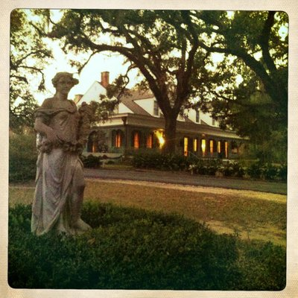
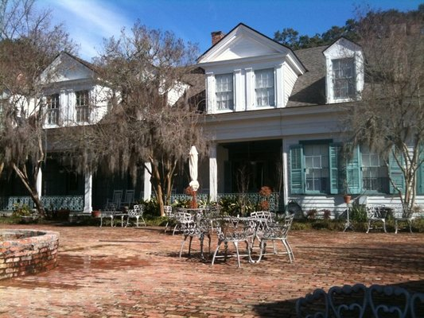

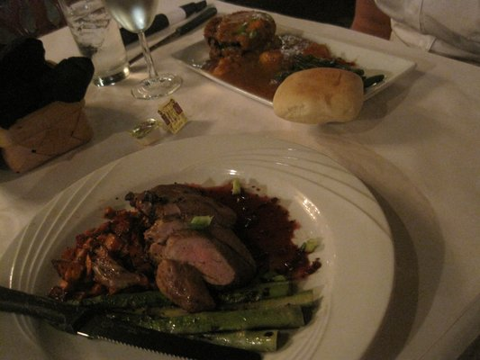
This is the food that is served at the restaurant at Myrtles Plantation.

