Michael E Arends
5/1/12
English212-005
Mr. Magee
Terry Bradshaw
Terry Bradshaw was born September 2, 1948 in Shreveport Louisiana and was the middle child of three boys. His football careers started at Woodland High School were in 1965 he led his team to the AAA High School Championship game which they lost to the Sulphur Tors 12-9. While at high school he also set a national record for the javelin toss at 245 feet which is close to the current Olympic record set in 2008 of 297.145 feet (1). During his time in high school he was featured in a sports illustrated article “Faces in the Crowd” which features outstanding high school athletes.
Bradshaw attended Louisiana Tech University in Ruston Louisiana as a junior he lead the bulldogs to a 9-2 record gaining 2,890 yards ranking first in the NCAA and got Louisiana Tech into the rice bowl were they won 33-13 over the university of Akron. And as a senior lead tech to an 8-2 record throwing 2,314 yards ranking third in the NCAA. His decrease in productivity was due to the team playing 1 less game then the year prior and because he was taken out of a lot of games during the second half because the team already had such a huge lead. His primary receivers were Larry C. Brewer and Thomas Allen Spinks both of which are still recorded among the top in receiving yards in Louisiana Tech History. Terry Bradshaw is still considered the best quarterback that ever played for Louisiana Tech University and was inducted into Louisiana Tech’s sports hall of fame as well as the College football Hall of Fame in 1996. In 2006 Terry Bradshaw donated his four Super Bowl rings, College Football Hall of Fame ring, Pro Football Hall of Fame ring, Hall of Fame bust, and a helmet and jersey from one of his Super Bowl victories to Louisiana Tech. He was quoted saying “I don't need [these things] to remind me of anything, I played in those games, and that's all the memories I need. All of this memorabilia represents blood, sweat and tears throughout my career, and it's nice to know that there is now a permanent home for it"(6).
In 1969 terry Bradshaw was considered by many NFL scouts as the most outstanding college football player and it was predicted by many analysts that he would be the first pick in the 1970 NFL draft. He was the first pick in the 1970 draft by the Pittsburg Steelers who the previous year had a record of 1-13 and gained the first pick by winning a tie-breaking coin flip against the Chicago Bears. Terry Bradshaw became the starting quarterback in his second season, during that year he played very in-consistent and threw more interceptions then touchdowns and was ridiculed by the media for his rural roots and preceded lack of intelligence and was given the nickname the “bayou Bumpkin. After many years in the NFL he eventually became one of the premier quarterbacks in the league. Bradshaw was the Quarterback when the Steelers were known as the “Steel Curtain” during which they were known for a powerful running game a punishing defense and the presence of a deep pass due to his strong arm. It is also when the Steelers started the Tradition known today as the “Terrible Towel” which started during the Steelers first playoff game with Terry Bradshaw as quarterback. It is considered the most famous and important years of the Steelers History
Terry Bradshaw’s best Season was in 1978 when he was named the NFL’s MVP (Most Valuable Player) and was also named ALL-Pro and All-AFC Leading his team to a record of 14-2 and leading his team to the AFC championship game. Completeing 207 of 368 passes for 2,915 yards and leading the league with 28 touchdown passes while also throwing 21 interceptions being the most thrown by any MVP at the time.
Terry Bradshaw played for the Pittsburg Steelers for 14 years, during his carrier Bradshaw threw for 27,989 yards and 212 touchdowns and had a regular season record of 107-51 and had an overall QB ranking of 70.9. He lead the Steelers to 8 AFC Championships carrier he won 4 Super bowls (9, 10, 13 and 14) helping the Steelers lead the NFL in most super bowl victories of all time and being only one of 7 teams to win it two years in a row. Even though the Steelers do not officially retire players uniform numbers they have not reissued his number since his retirement and it is generally assumed that they will never give his number to another player. He also won a large number of awards during his carrier including the Super bowl MVP twice (13, 14) and was selected to 3 pro-bowls (1975, 1978 and 1979), he was also selected to the first-team All-Pro selection in 1978 was the NFL MVP in 1978 and was ranked 50th in the NFL list of best Players of all time (list made in 2009) (2).
Bradshaw wrought his first autobiography, man of steel published in 1979 were in he wrote about how he felt like he was bottoming out after the divorce of his first wife Melissa Babich and was going through a shoulder injury. The turnaround came when, according to his memoir, Bradshaw, already a born-again Christian, had a revelation "I had separated myself from God. I lived only for Terry Bradshaw, not for God. I tried to be one of the boys and went to every honky-tonk I could find and chased women and behaved in a way that was totally alien to anything I had ever known before … my whole life was out of control … I was trying to be someone else and was doing a rotten job of it”(3). He felt as though he was going through a second conversion very well summed up by a very humble emotional prayer he made "I just put my head in my hands and began to cry and tremble all over and finally I blurted out, 'Here I am, God. I've tried to handle it all by myself and I just can't get the job done. So I'm placing my life in your hands. I need some peace of mind and I know you can give it to me” (3). Afterwards Terry Bradshaw said he suddenly felt stronger mentally and physically and felt like he was back to his old self.
After he retired from the NFL he had a very successful carrier as a sports broadcaster. After retiring from football in 1983 he quickly signed a contract with CBS and became a NFL game analyst in 1984, where he was a play-byplay announcer with Verne Lundquist. He was promoted in 1990 to an analyst for NFL today and Fox NFL Sunday where he hosted two regular features Ten Yards with TB and They Terry Awards. He also appeared on the first broadcast of NASCAR on FOX where road with Dale Earnhardt at Daytona International Speedway.
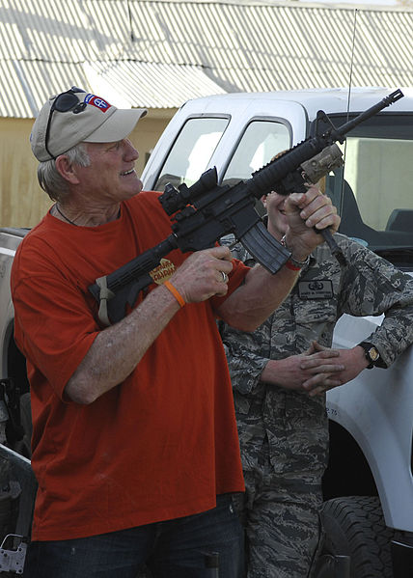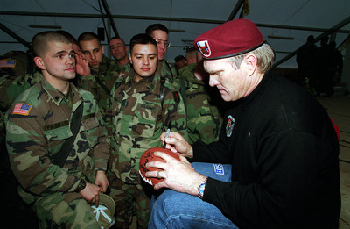
Terry Bradshaw doing Mission with USO Nov. 6, 2009, at Bagram Airfield, Afghanistan(Right)
Terry Bradshaw with 82nd Airborne with USO Mission on Dec, 23 1999 at Camp Bondsteel Kosovo(Left)
Bradshaw has also written/co-written a total of five books and recorded six albums of country western and gospel music. His cover of "I'm So Lonesome I Could Cry" hit Top 20 on Billboard's country chart. Bradshaw also appeared in several movies including Hopper in 1978 Sally field in 1981 The cannonball run in 1980 and The Adventures of Brisco County jr in 1994 Bradshaw has also made multiple cameo appearances mostly as himself including The Jeff Foxworthy Show, Everybody Loves Raymond, Married... with Children, The League and Malcolm in the Middle. He has also appeared on multiple talk shows including Jay Leno, Jimmy Kimmel Live, and the Ellen DeGeneres Show and In 2012 Terry Bradshaw became a spokesperson for Nutrisystem. On October 11, 2001 Terry Bradshaw received a star on the Hollywood Walk of Fame being the first and only NFL player to do so (since 2012).

Bibliography
- "Javelin Throw Men Â." Javelin Throw Men. Web. 20 Apr. 2012.
http://www.olympic.org/athletics-javelin-throw-men
- "Terry Bradshaw." Pro-Football-Reference.com. Web. 20 Apr. 2012.
http://www.pro-football-reference.com/players/B/BradTe00.htm
- Bradshaw, Terry. Man of Steel. Zondervan, 1979. Print.

- "Terry Bradshaw." Wikipedia. Wikimedia Foundation, 11 Apr. 2012. Web. 21 Apr. 2012.
http://en.wikipedia.org/wiki/Terry_Bradshaw
- "Terry Bradshaw." IMDb. IMDb.com. Web. 22 Apr. 2012.
http://www.imdb.com/name/nm0103537/
- "Bradshaw Keeps Memories, Gives Rings to AlmaÂ mater." ESPN.com. Web. 24 Apr.
2012 http://csnbbs.com/showthread.php?tid=26667

Pictures in Public Domain
http://www.defense.gov/photos/newsphoto.aspx?newsphotoid=2663
http://commons.wikimedia.org/wiki/File:Terry_Bradshaw_M4_carbine_Bagram_AF_Base.JPG

