A Celebration of the
Leadership and Accomplishments of
Don P. Giddens, PhD

Date: Friday, June 6, 2008  Location:  Georgia Institute of Technology  The Parker H. Petit Institute for Bioengineering and Bioscience  Georgia Tech, Room 1128  315 Ferst Drive • Atlanta, GA 30332-0363  Agenda (Web Version)  Agenda (Printable pdf Version)  Registration  Lodging Information  Schedule:  8:30 am - 9:00 am Continental Breakfast  9:00 am – 5:00 pm Symposium  5:00 pm - 6:00 pm Reception | 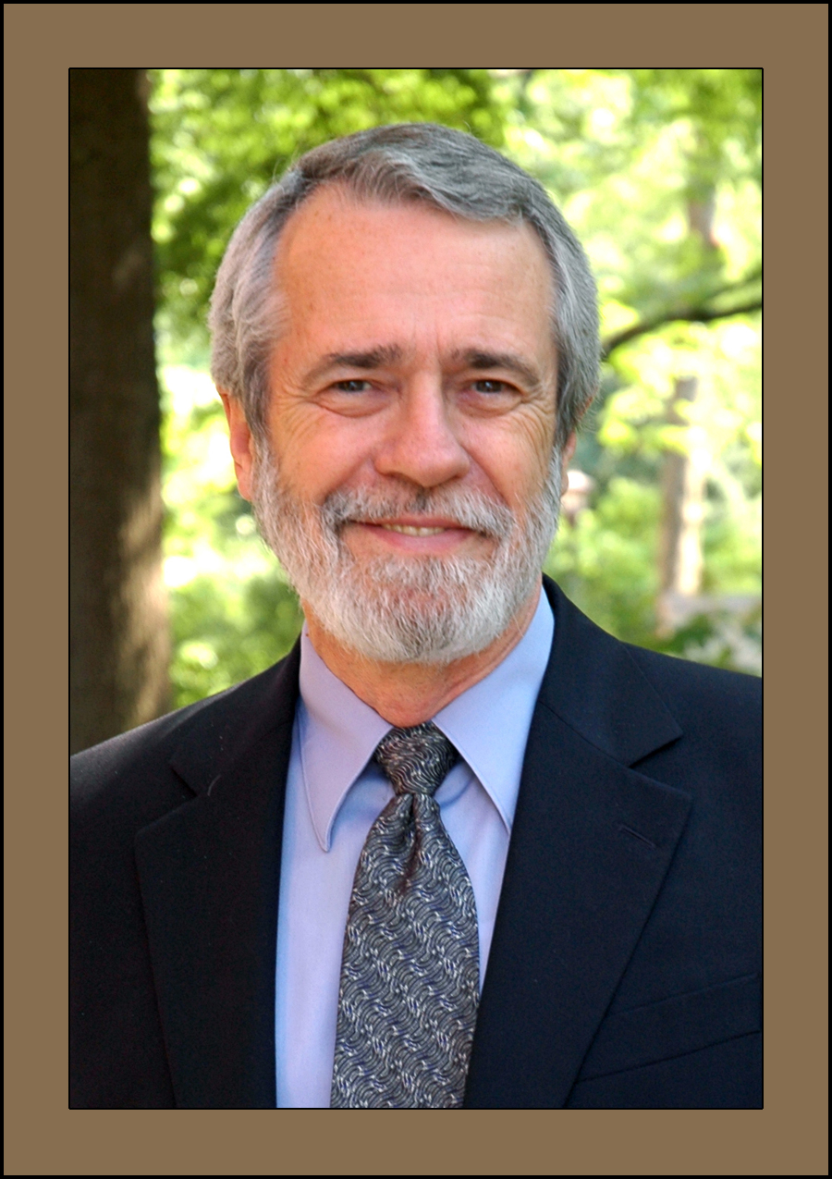  Don P. Giddens, PhD  Dean – Georgia Tech College of Engineering  Lawrence L. Gellerstedt, Jr. Chair in Bioengineering  Georgia Research Alliance Eminent Scholar

SCHEDULE
SCHEDULE

