Advanced Use of Headers and Footers in Page Numbering

Graduate students are often required to number the first page of a section differently from the subsequent pages. The following example demonstrates how to have a centered number on the bottom of each first page and a right-justified page number at the top of subsequent pages.

To get pages numbered in center bottom on the chapter title page and on upper right hand corner on the following pages:

- Insert a break on the title page immediately after the chapter title, (Figure 1), and select the “continuous” option (Figure 2).

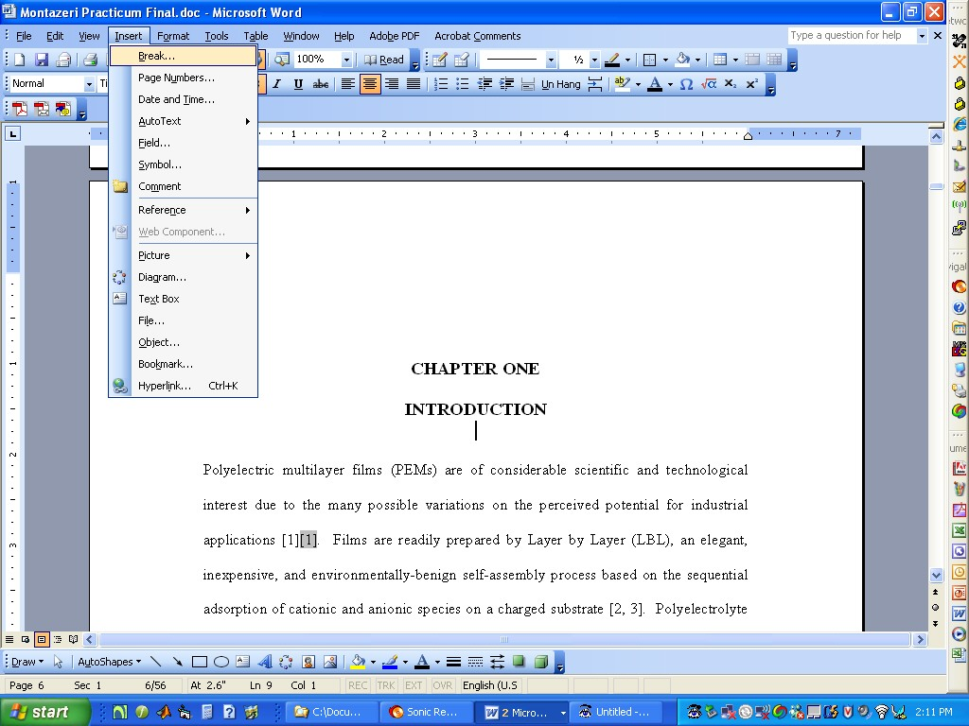

Figure 1: Inserting a break immediately after the chapter title.

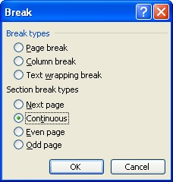

Figure 2: Selecting the continuous break option.

- Go to the footer on the bottom of the next page and hit the “link with previous” button to unlink footers between the different sections (Figure 3).

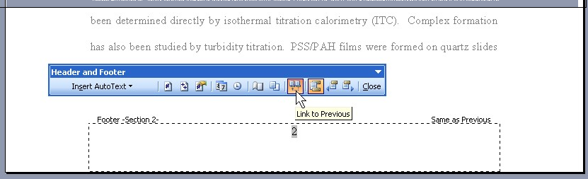

Figure 3: Unlinking the footer of one section from the footer of the previous section.

- Delete the page number from the footer.
- Go to the header of this page.
- Hit the “link with previous” button again to unlink headers between the different sections (Figure 4).

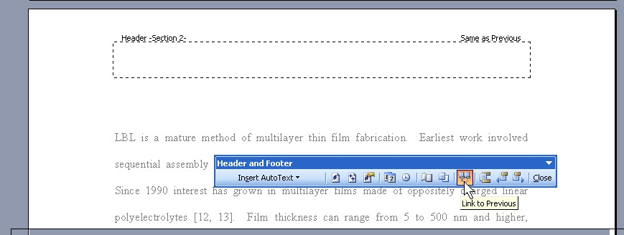

Figure 4: Unlinking the header of one section from the header of the previous section.

- Move the cursor to the right hand position of the header.
- Hit “insert page numbers” (Figure 5).

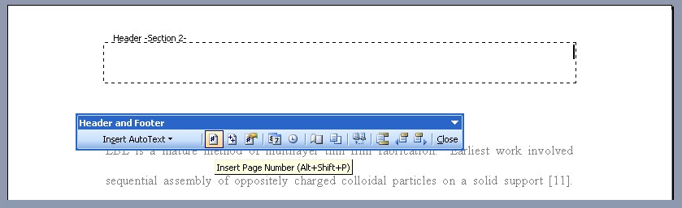
Figure 5: Inserting page numbers in the upper right hand corner.

- Hit “format page number” (Figure 6).

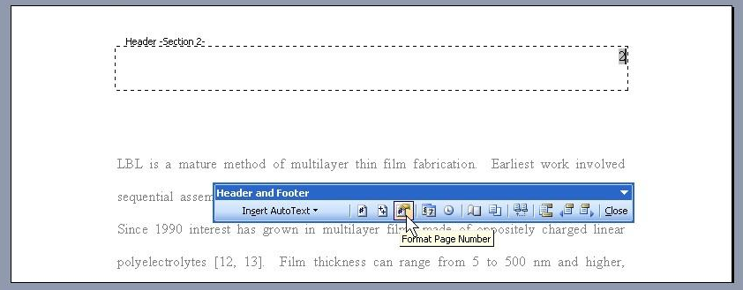

Figure 6: Formatting the page number so that it continues from the numbering of the previous section.

- Select “continue from previous section” (Figure 7).

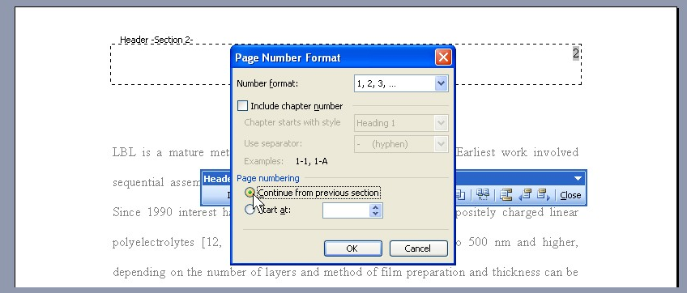

Figure 7: Selecting “continue from previous.”

- Close headers and footers.

